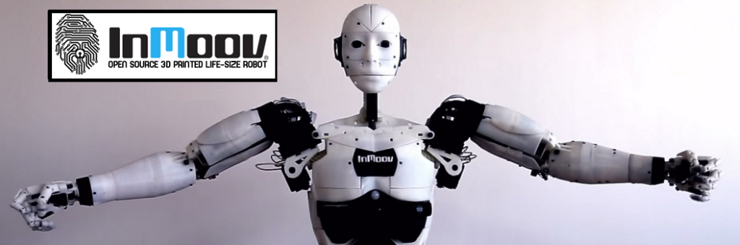

**Presentation & Subject Analysis**

**Identification:**

|  |  |
| --- | --- |
| Project Title | Robot Cognitif |
| Project Number | 65 |
| Team Referent | MARTIN Jérémy |
| Other members in team | EKHTERAEI Aria, GUILLAUME Thomas, MEZOUAR Chloé |
| Team Mentor | Jean-Philippe LELIEVRE |
| Project Partner | DaVinciBot |

**Work done since the last PRM review:**

-An algorithm is able to create a dataset of a person, taking many pictures with the webcam of the computer and saving them in a file, thanks to the OpenCV librairy.

-Then, we can train the machine with the dataset in order to be able to differentiate people without any help with TensorFlow and Cuda.

-Another algorithm allows to recognize approximatively few persons of the dataset train.

-We made an installation guide for anaconda 3, tesorflow cpu and gpu and cuda.

-Under Linux, we created a new algorithm to add landmarks around the face with the Dlib library.

-We made a test dataset of 6 persons.

-With the 3D-printed head of the robot and the camera put in its eye, we tested the system and it worked.

**Difficulties encountered:**

-The installation of tensorflow and cuda is quite complicated. For now, Jeremy is the only one who succeeded installing it.

-The rate of success is too low beyond 4 persons in the dataset.

-The creation of the dataset is a bit too long and the quantity of memory required by the database can be an issue when it will run on an arduino.

-How works the webcam and the optimization of the process analyzing.